**OOP LAB 7 Tasks**

**Task 1 :**

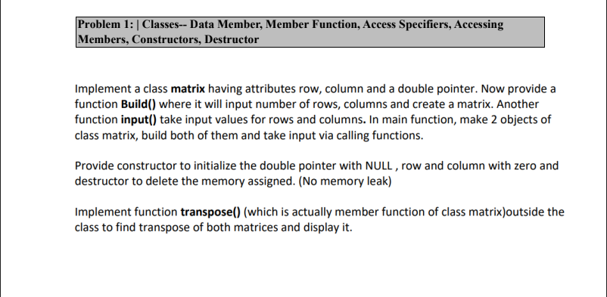

**Task 2:**

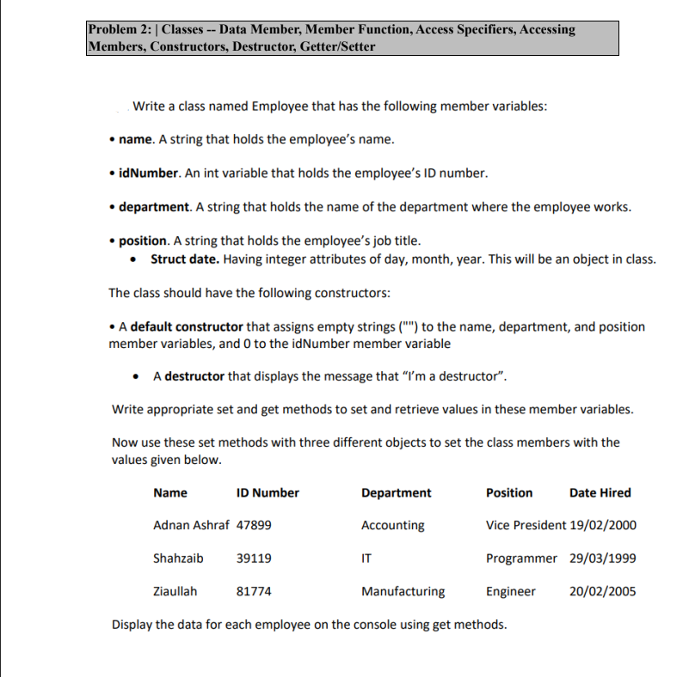

**Task 3 :**

